Installing and Running Jenkins as a Standalone Application.

Jenkins is an open source automation server that helps to streamline and centralize the build process and maintain the continuous integration process of a code base. If you want to set it up and play around to test its capabilities you can do it in few simple steps!

* Download the Jenkins WAR.

Go to the [Jenkins download page](https://jenkins.io/download/) and download the “*Generic Java package (.war)*”.



* **Start Jenkins.**

Jenkins comes with an embedded [Winstone](http://winstone.sourceforge.net/) server; therefore enabling it to run as a standalone application. For this tutorial I’m going to use it in the standalone form. However, you could place the .WAR file in an application server of your choice and use it if you wish to do so. To run as a standalone application, first copy the “*jenkins.war*” file in to a suitable location in your system and open a command line window from there and run the following command;

***java -jar jenkins.war***

Wait for the console output to print ‘*Jenkins is fully up and running’* and that’s it! You have successfully started the Jenkins server! Now go to your browser and type the url: [*http://localhost:8080/*](http://localhost:8080/login?from=%2F)and you should see a screen similar to the one below, prompting for the initial administrator password that was generated in the previous step. Input the password and click ‘*Continue*’.

*Jenkins starts on the port 8080 by default. To override the default settings follow instructions provided in this* [*link*](https://wiki.jenkins-ci.org/display/JENKINS/Starting+and+Accessing+Jenkins)*.*

[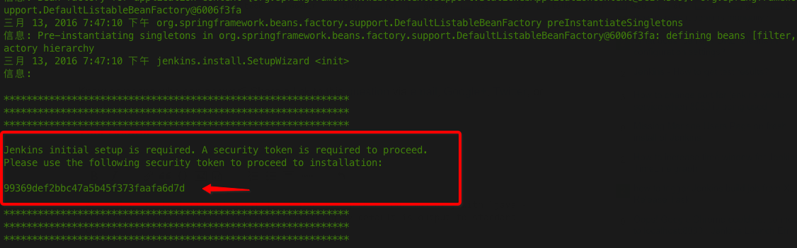](https://i.stack.imgur.com/kNhMQ.png)

*Access code for first enter*

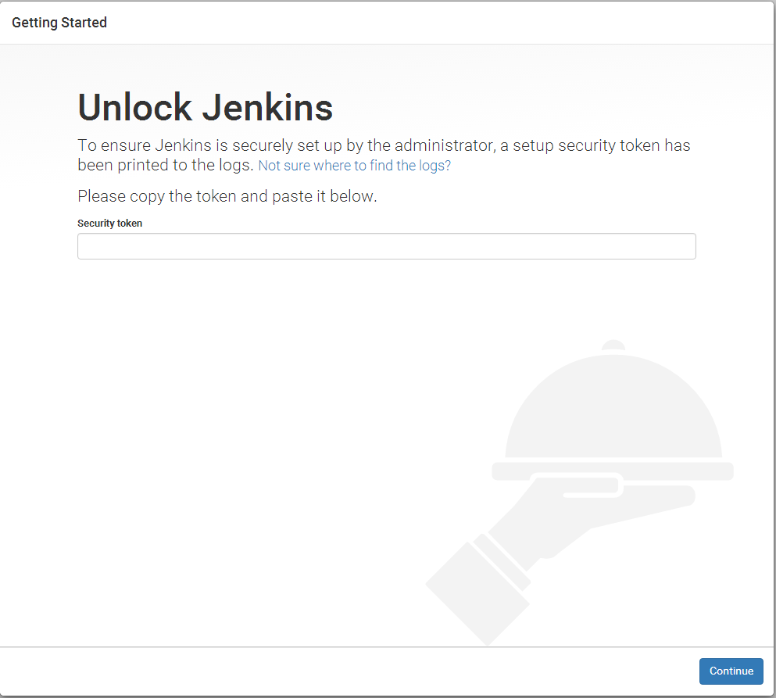

In the next screen you will be asked to install necessary plugins for Jenkins. These plugins are the ones that actually help Jenkins do its magic! They enable the integration of various platforms with Jenkins. You could choose to let Jenkins download most basic plugins by itself or customize as you prefer. There’s myriad of plugins available for all the popular build tools and version control systems.

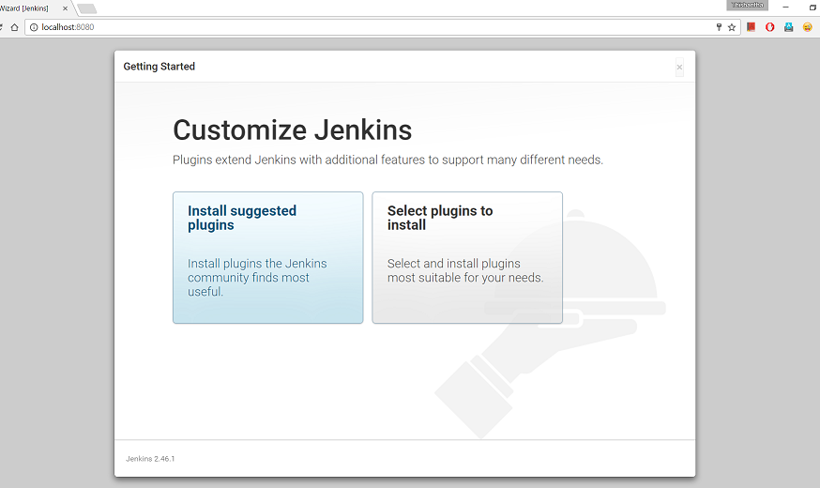

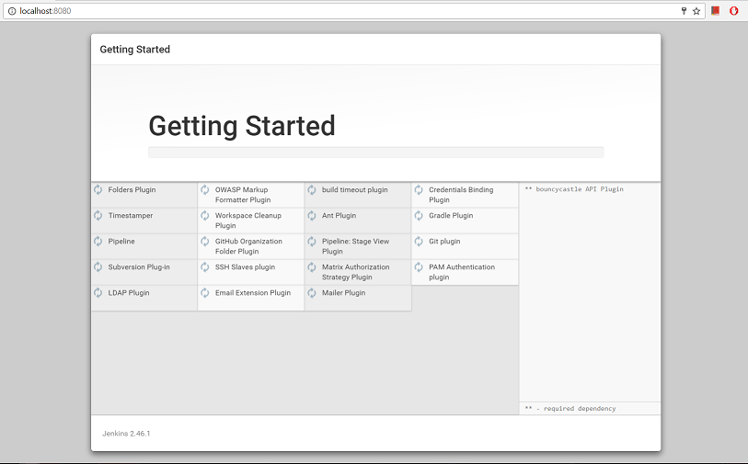

You will be prompted to create an Admin user in the next screen once the plugin installation is complete.

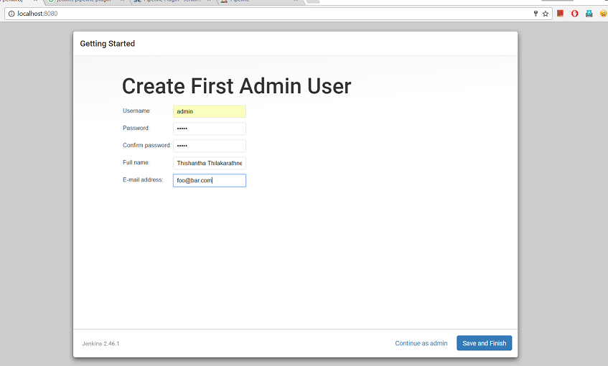

Once finished, click *Save and Finish* and now you can proceed to the Jenkins dashboard where you can start creating jobs for your projects.

